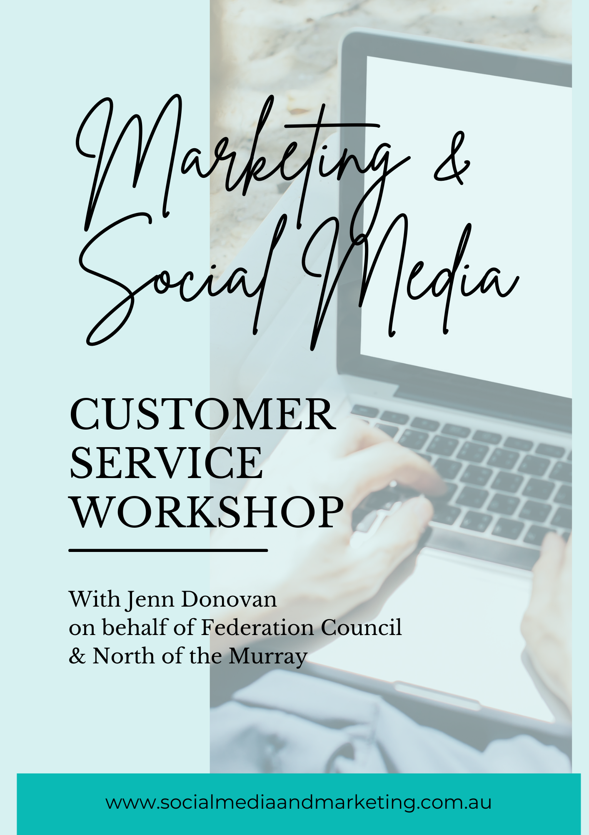Customer Focus Workshop

Notes:

A-HA Moments

To Do List: | Things to Learn More About:
Customer Focus Workshop

Notes:

A-HA Moments

To Do List: | Things to Learn More About:

Customer Focus Workshop

AUDIT Your Social Media Strategy:

Look at your last 15-20 Social Media Posts and tick which strategy they fall into (it can be more than one)

Engagement Strategy | Brand Awareness Strategy | Growth Strategy | Lead Generation Strategy | Sales Strategy

Now that you have assessed social posts against a strategy, identify the 3 areas you think you need to work on most. Why do you think these areas are the ones you need to focus on?
1. Area to improve:_________________________________________________________
2. Area to improve:_________________________________________________________
3. Area to improve:_________________________________________________________

Customer Focus Workshop
AUDIT – Community Building

What activities do you do, or does your business do, today, to help you build a community of loyal followers?

What could you/should you be doing?

What’s holding you back? Use the “to do list” or the “things to learn more about” to prompt your thoughts once leaving today, so this doesn’t become a “nice to do” thing in your business!

Customer Focus Workshop
AUDIT – Branding

Is my brand consistent across all platforms and marketing? Colours, fonts, tone, voice, language? What needs adjusting?

What is your product, service, or message?

List your brand values – are you communicating them and attracting the right audience?

Customer Focus Workshop
AUDIT – Branding continued ….

Am I on the right platforms for my business to attract the right audience?

Is my niche clearly defined?

Have I positioned my brand where I need to?

Customer Focus Workshop
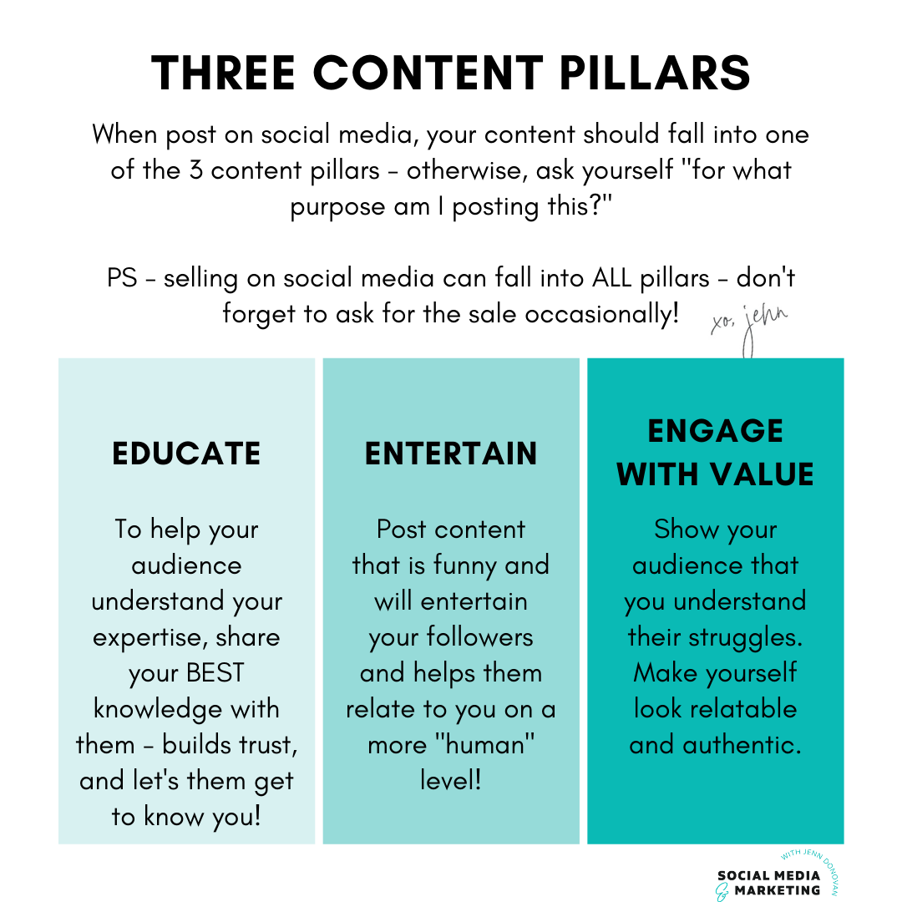
Notes:

Customer Focus Workshop
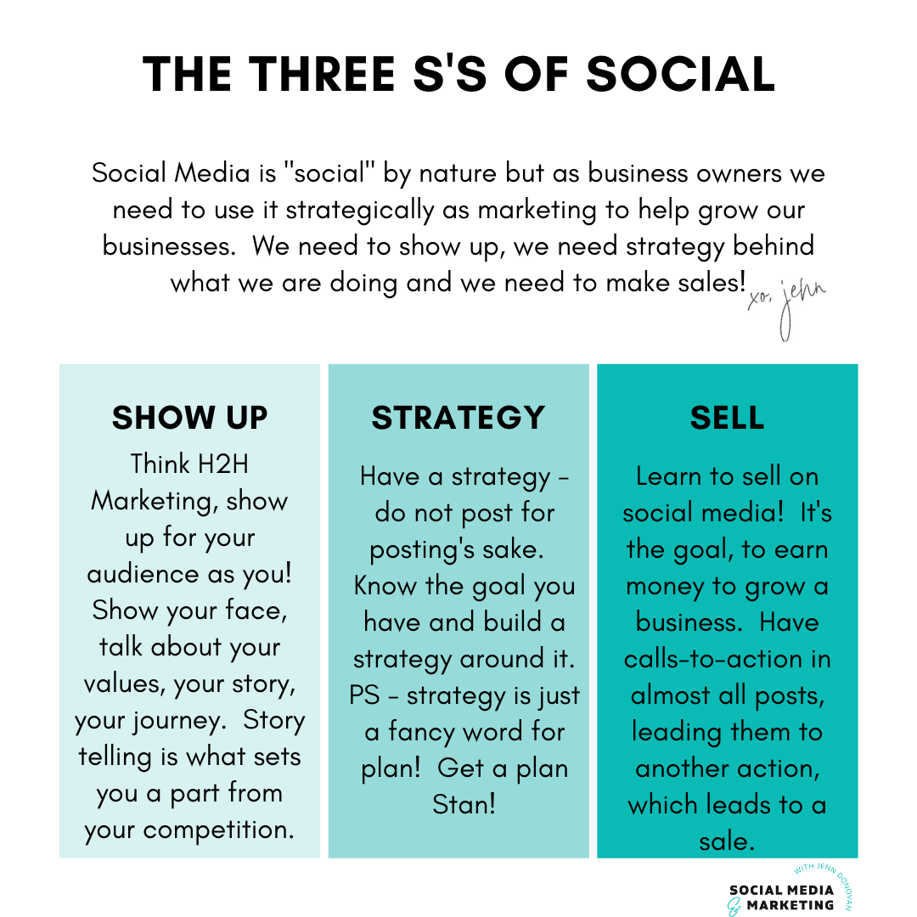
Notes:

Notes:

A-HA Moments

To Do List: | Things to Learn More About:
Notes:

Notes:

Social Media Mastery Self-Assessment

Take a moment to assess yourself in the 12 key areas that have been identified as central to success using social media for your marketing. This exercise is designed to help you identify areas for possible improvement that can help you accelerate the profitability of your business.

Circle the score that best describes where you are right now. Then identify the 3 areas you feel, if you improved, would have the biggest impact on your business results.

Success Tools & Traits | Strength |  |  | Average |  |  |  | Weakness
I have clearly defined goals for my social media | 5 | 4 |  |  | 3 | 2 |  |  | 1
I have a clear and defined target audience | 5 | 4 |  |  | 3 | 2 |  |  | 1
Have a solid social media marketing strategy | 5 | 4 |  |  | 3 | 2 |  |  | 1
I am on the right platforms, where my client is | 5 | 4 |  |  | 3 | 2 |  |  | 1
I show up for my clients consistently (as me!) | 5 | 4 |  |  | 3 | 2 |  |  | 1
Consistently produce highly quality engaging content | 5 | 4 |  |  | 3 | 2 |  |  | 1
I follow the rules of the 3Es – entertaining, education, engaging with value | 5 | 4 |  |  | 3 | 2 |  |  | 1
I strategically use my social media to reach my goals | 5 | 4 |  |  | 3 | 2 |  |  | 1
My audience knows what I sell and how to buy from me | 5 | 4 |  |  | 3 | 2 |  |  | 1
My audience knows my brand values | 5 | 4 |  |  | 3 | 2 |  |  | 1
My audience knows who I am, what I want to be famous for & my story | 5 | 4 |  |  | 3 | 2 |  |  | 1
I have a clear and defined brand strategy across all platforms | 5 | 4 |  |  | 3 | 2 |  |  | 1

Tally up your score My score was __________
Now that you have assessed yourself in the 12 key areas, identify the 3 areas you think you need to work on most. Why do you think these areas are the ones you need to focus on?
1. Area to improve:_________________________________________________________
2. Area to improve:_________________________________________________________
3. Area to improve:_________________________________________________________

Social Media & Marketing Australia
With Jenn Donovan

Helping Small Business Owners
- Make Marketing a Priority
- To Earn What They’re Worth
- Make More of a Difference in their Communities.

T 0428 324 149
E jenn@jenndonovan.com.au
W www.socialmediaandmarketing.com.au

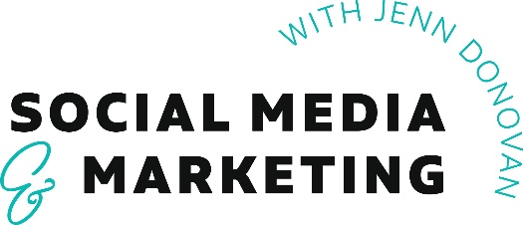

Australia’s leading online marketplace for Rural and Regional Small Businesses. Supporting small businesses to sell online, grow and become more profitable to make a bigger difference in their own communities.

www.spendwithus.com.au

